André Gras
42064208
CSE 5350
Term Project Part 1: Random Geometric Graph

Executive Summary

Introduction

This project generates a random geometric graph in a unit square by taking in number of vertices and the average degree. From those inputs, the program estimates r and plots vertices randomly within the unit square and creates undirected edges between vertices if their distance is less than r. I have created graphs with various benchmarks and found that even under the largest benchmark testing, my graph is generated in under a minute. With small benchmarks, the process takes less than a full second.

Summary
Square Random Geometric Graph w/o File I/O time
N | Expected Avg. Degree | r | Time Taken (s) | Max Deg. | Min Deg. | Real Avg. Deg. | # of Edges
1000 | 32 | 0.100925 | 0 | 46 | 5 | 29 | 29,642
8000 | 64 | 0.0504627 | 0 | 91 | 14 | 61 | 489,530
16000 | 32 | 0.0252313 | 0 | 56 | 6 | 31 | 500,706
16000 | 64 | 0.0356825 | 0 | 93 | 18 | 61 | 991,148
32000 | 64 | 0.0252313 | 3 | 98 | 17 | 62 | 2,004,728
32000 | 128 | 0.0356825 | 3 | 176 | 32 | 124 | 3,969,086
64000 | 64 | 0.0178412 | 12 | 97 | 15 | 63 | 4,032,878
64000 | 128 | 0.0252313 | 11 | 174 | 32 | 125 | 8,011,772
128000 | 64 | 0.0126157 | 51 | 106 | 14 | 63 | 8,105,808
128000 | 128 | 0.0178412 | 54 | 179 | 27 | 126 | 16,138,446

As we can see from this chart, number of vertices matters more than density when it comes to time taken, although density plays a larger role when the vertices are larger. We can also see that as the edges double, the time taken does not necessarily double, so our algorithm's time complexity is in terms of vertices. My method is strongest when there are more dense graphs as opposed to sparse ones, and also when the graph has less vertices. My graph is weakest with more vertices. As vertices double, time seems to quadruple, leading to an estimate of O(V²)

Square Random Geometric Graph w/ File I/O Time and Plotting
N | Expected Avg. Degree | r | Time Taken (s) | Max Deg. | Min Deg. | Real Avg. Deg. | # of Edges
1000 | 32 | 0.100925 | 3 | 46 | 5 | 29 | 29,642
8000 | 64 | 0.0504627 | 3 | 91 | 14 | 61 | 489,530
16000 | 32 | 0.0252313 | 3 | 56 | 6 | 31 | 500,706
16000 | 64 | 0.0356825 | 3 | 93 | 18 | 61 | 991,148
32000 | 64 | 0.0252313 | 3 | 98 | 17 | 62 | 2,004,728
32000 | 128 | 0.0356825 | 3 | 176 | 32 | 124 | 3,969,086
64000 | 64 | 0.0178412 | 13 | 97 | 15 | 63 | 4,032,878
64000 | 128 | 0.0252313 | 14 | 174 | 32 | 125 | 8,011,772
128000 | 64 | 0.0126157 | 48 | 106 | 14 | 63 | 8,105,808
128000 | 128 | 0.0178412 | 49 | 179 | 27 | 126 | 16,138,446

As we can see, the file writing operation consumes more time as we are outputting the vertices to a file for plotting. The first benchmark takes 3 seconds as well because it must create edge relations in the vertex plotting as well. I cannot quite explain why the 32000 only takes 3 seconds as well. Sometimes it was taking longer but I took the average of the tests.

Programming Environment Description
I used the Ubuntu Bash on Windows and Visual Studio Code as my IDE. I used C++ as my language, pulling from the standard libraries. The specs of the computer used are 8 GB of RAM, Windows 10 OS, CPU clock rate of 3.5 GHz (i5 2500k slightly overclocked with Hyper 212+ fans and heat sink), and Gigabyte motherboard. I use gnuplot through my Ubuntu Bash on Windows using a pipe in my C++ code to plot my graphs. The program never exceeded 35% of CPU and used 220 MB of RAM at most.

Reduction to Practice

Data Structure Design
I used Node struct to embody vertices, with x, y position and edges list. I made the list of edges a vector of Node* as well. An example of the data structure would be:
1 2 3 4 5 6 7 8
3 5 1 1 1 2 2 1
4 7 4 3 2 3 4
5 6 7 8 6 5
8 7
Where the first row across is the vector of Node pointers and the columns are the vector of Node pointers inside each vertex.

Algorithm Descriptions
I linearly created vertices using a for loop, then used a while loop nested in a for loop to compare the positions of the vertices, adding edges as I checked distances. That algorithm has an estimated time complexity of O(2V), as the nested loops sweep through vertices twice. The space complexity is not that bad since we are using pointers, so it stays at estimated O(V). I then went linearly through the vector in a similar fashion to calculate the minimum and maximum by comparing Node n and n+1.
For estimating r, I divided the average degree by PI*N, then took the sqrt() of that quotient.
For the random positions, I used the c++ math library ((double) rand() / (RAND_MAX)), which returns a pseudo-random number between 0 and 1.
For calculating distance, I checked each node n with node n+1 and used the classic distance formula (sqrt((x₁ - x₂)² + (y₁ - y₂)²)).
For calculating minimum and maximum degree and total edges, I swept through the vector setting the minimum number to min and the maximum to max and totaling the size of their edge list vectors.

Algorithm Engineering
I used these algorithms because they were the simplest method of achieving the goal. They work in linear time (approximately) as the times taken as vertices doubled, would go up by 4 times. I should do further benchmark tests past 128,000 to verify that the time is exponential and not linear, but my data suggests exponential. Without writing to file, the time was different, but the only way to make plotting in c++ work well was to write to a file and plot using gnuplot. The writing to file operation is slightly costly. The algorithm most likely works on a O(V²) time complexity from the nested loop sweep.

Verification
Plot of 1000 vertices with average degree 32
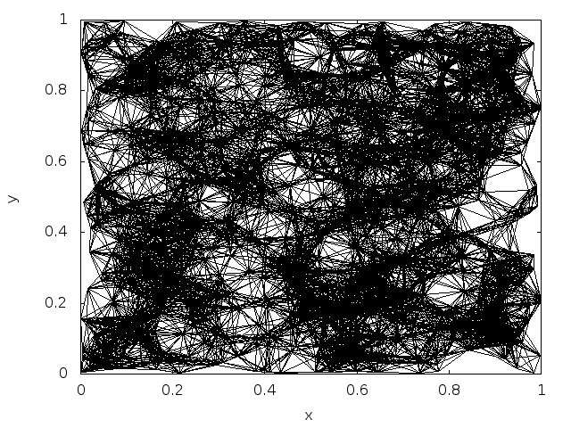
Plot of 8000 vertices w/o edges 8000 Verts. Degree Distribution Plot (avg. deg = 61)
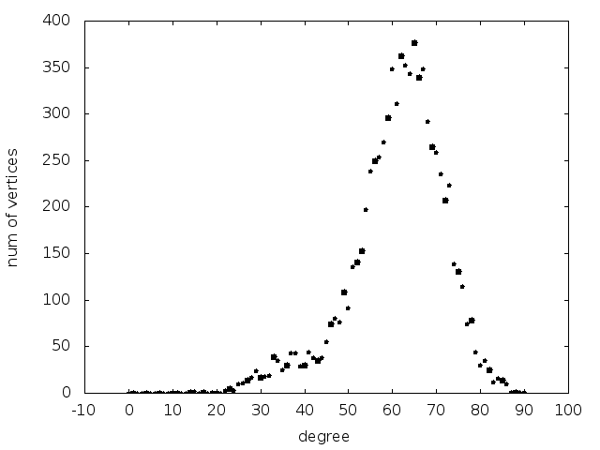
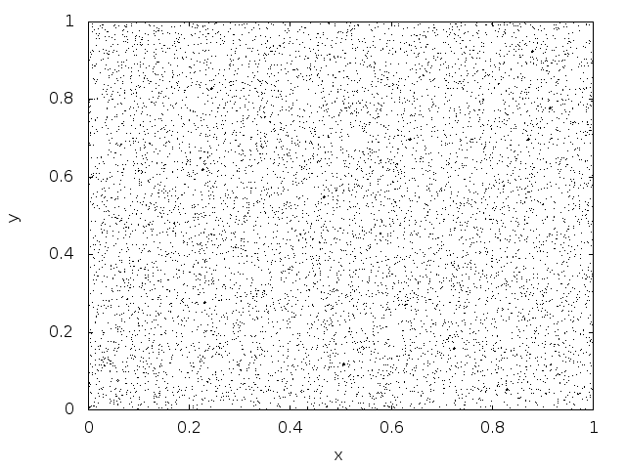

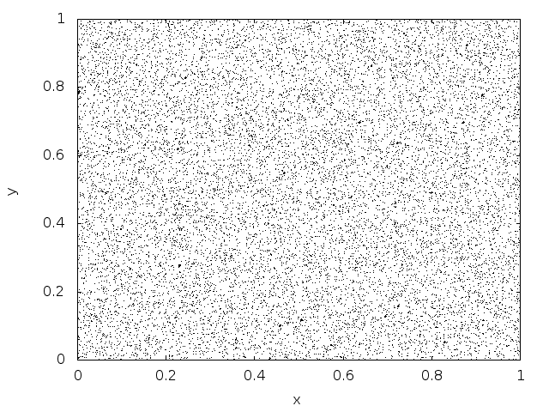
Plot of 16000 vertices w/o edges 16000 Verts. Degree Distribution Plot
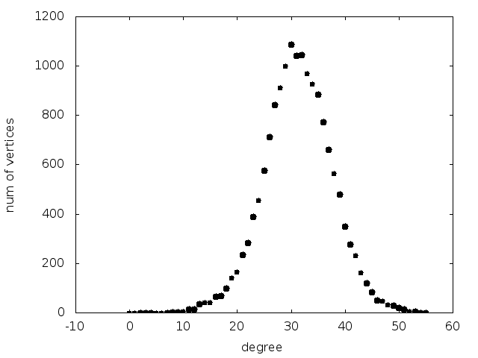
(avg. deg = 31)

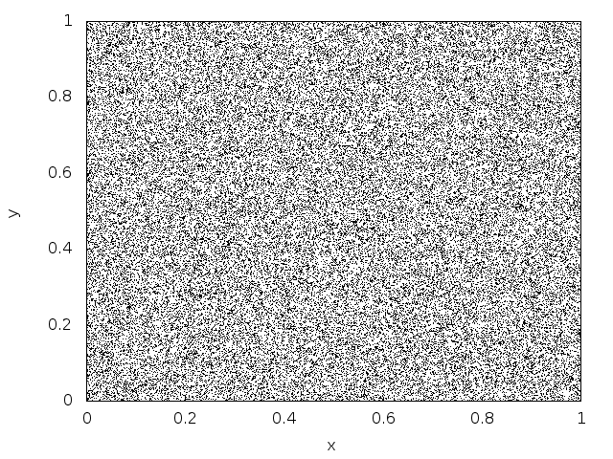
Plot of 64000 vertices w/o edges
64000 Verts. Deg. Distribution
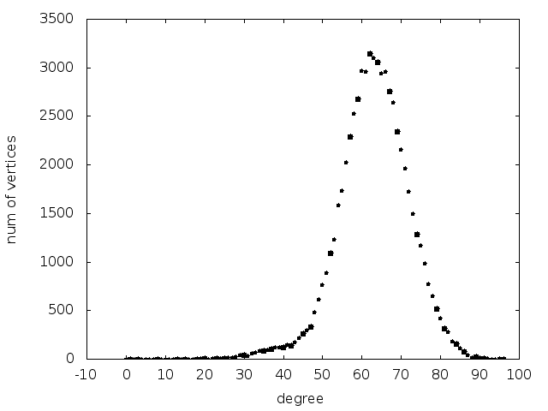
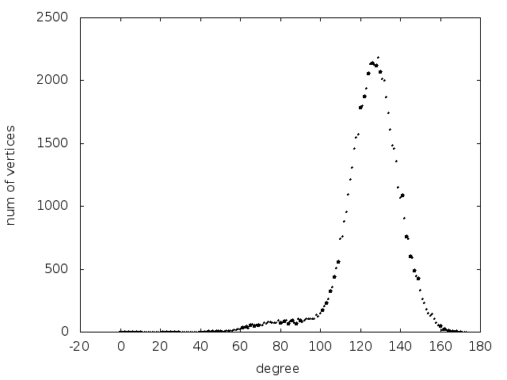
(avg. degree = 63) (avg. degree = 125)

Plot of 128000 vertices w/o edges
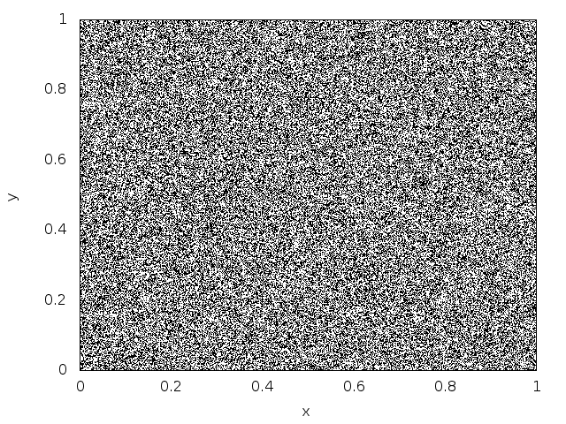
128000 Verts. Deg. Distribution
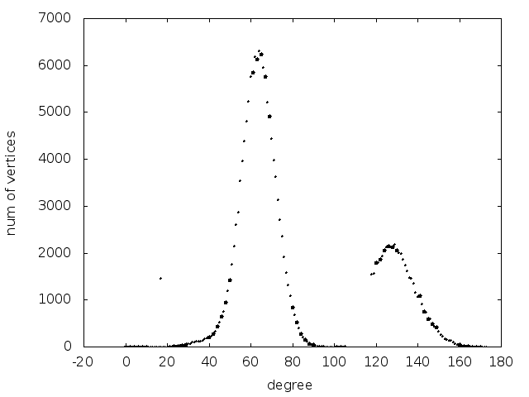
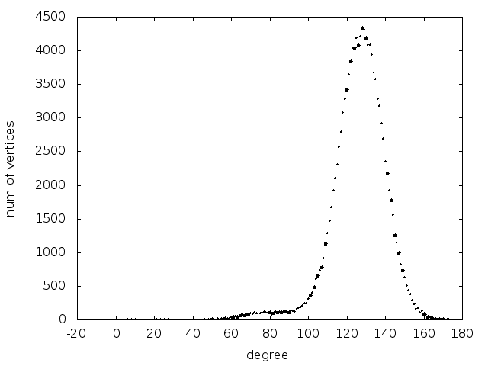
(avg. degree = 63) (avg. degree = 126)

Running Time vs. Number of Vertices Running Time vs. Average Degree
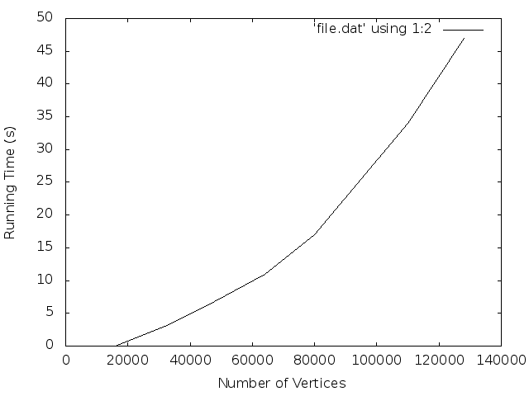
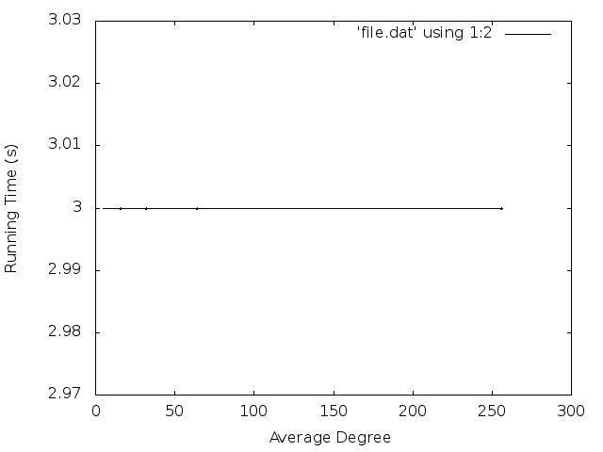

From these graphs, we can see that the space complexity of larger graphs is exponential and the complexity with respect to average degree is constant time.

References
[1] Chen, Zizhen. Backbone Determination in Wireless Sensor Network. February, 14, 2018. PDF.
[2] Kenniche, Hichem; Ravelomananana, Vlady. Random Geometric Graphs as Model of Wireless Sensor Networks. PDF.
[3] Williams, Thomas; Kelley, Colin. gnuplot 5.2: An Interactive Plotting Program. http://www.gnuplot.info/docs_5.2/Gnuplot_5.2.pdf. 2017.

